Procedure to Check Sunshine Claim Status
To check Sunshine claim status need to login to below URL.
URL : https://provider.sunshinehealth.com/careconnect/
Below is the screenshot of the page, need to Enter the username, then need to click on Log in to get the option to enter the password
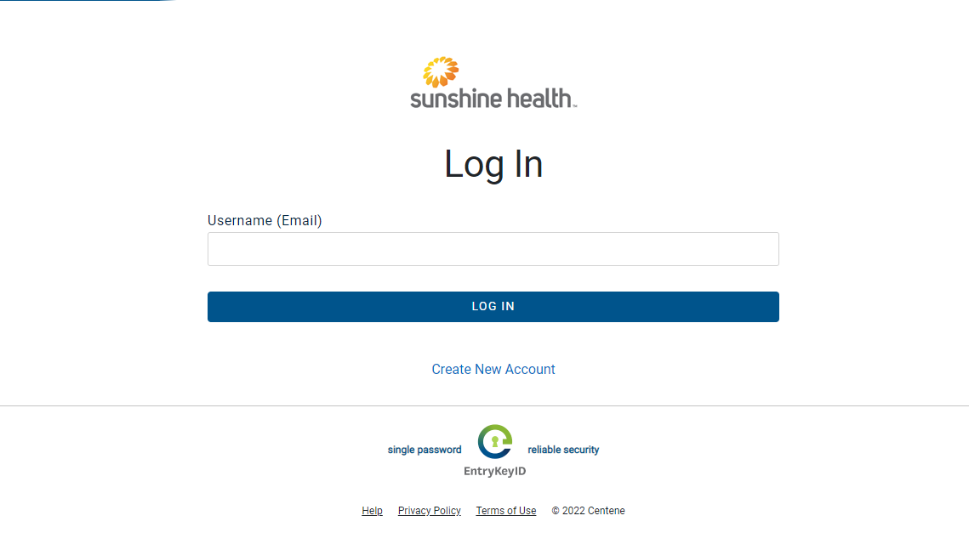
Now enter the password, and click on Log in to login to the portal.
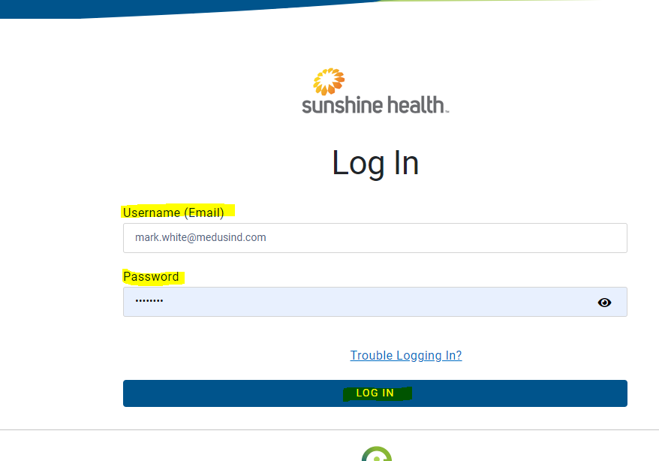
Once logged in, need to select the payer or plan type on the center top of the page.
Now click on the Claims on the top of the screen with "$" to check the claim status.
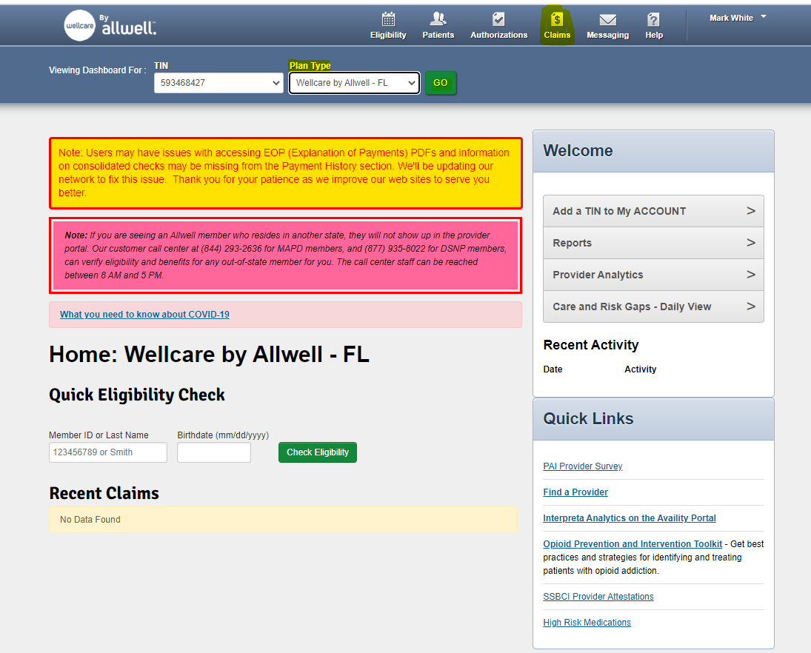
Then Click on the Change Date to get the option to enter Patient ID and Date of service to search for the claim.
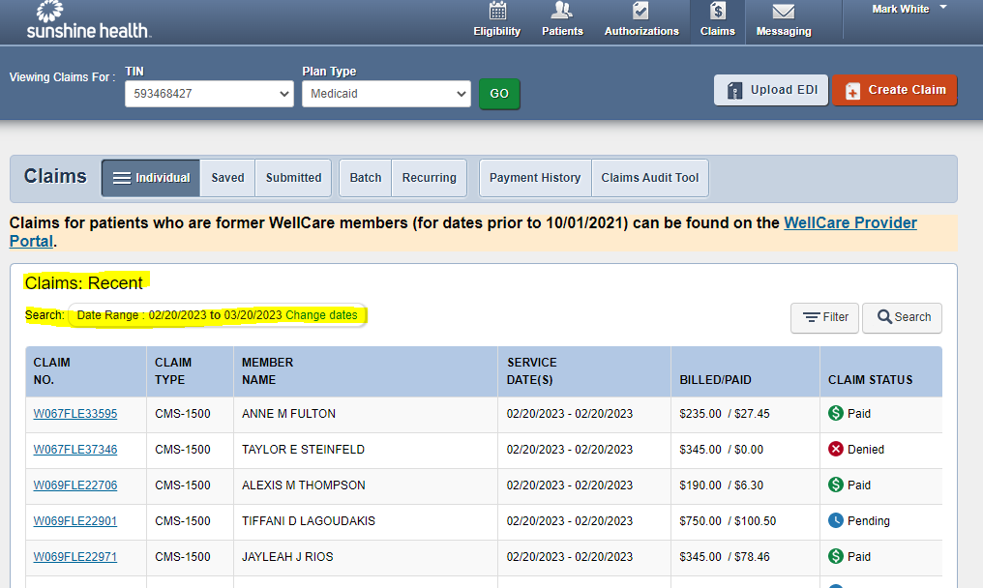
Required field to check claim is Member ID and date of service or Last name, Date of Birth and Date of service.
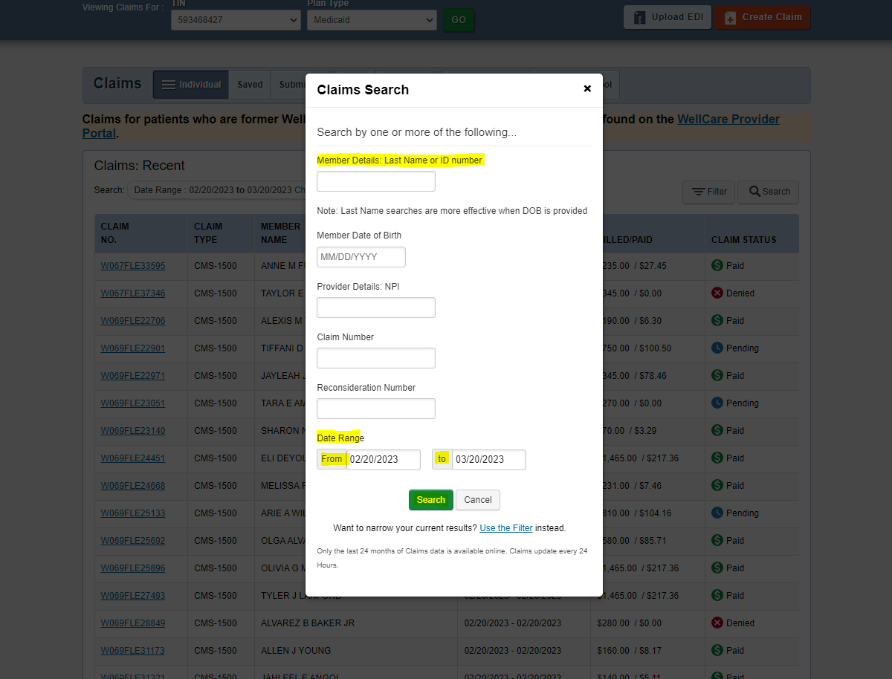
To get the patient details need to login to Medclarity.
Login to Medclarity - > Select “Orlando” in Enterprise -> Type the first word of the Entity name -> Click the Practice name from the Business Entity Search.
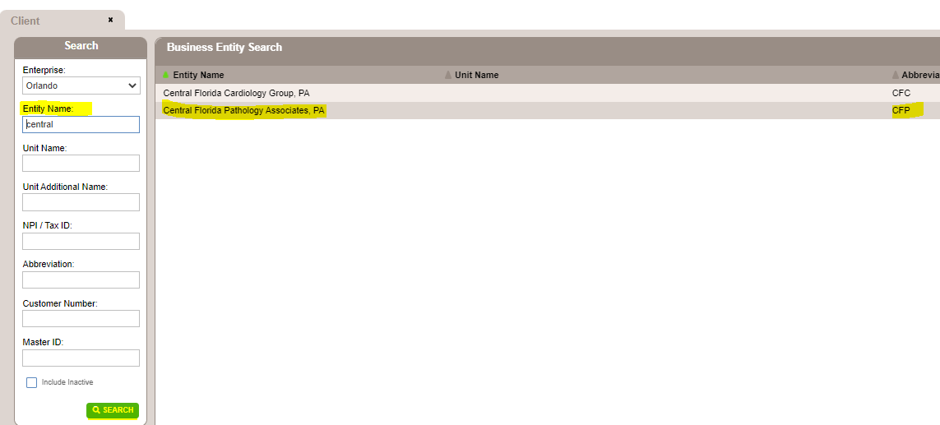
Once the practice opens, click the “Reimbursement” with the "$" Symbol
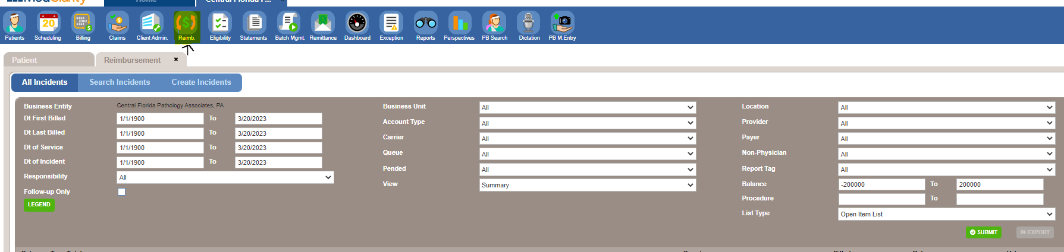
Then Click on dropdown in Queue and select Queue for No response claims.
Then Click the dropdown in the View tab and select “Details” and click on Submit to view the list of claims in the Queue.

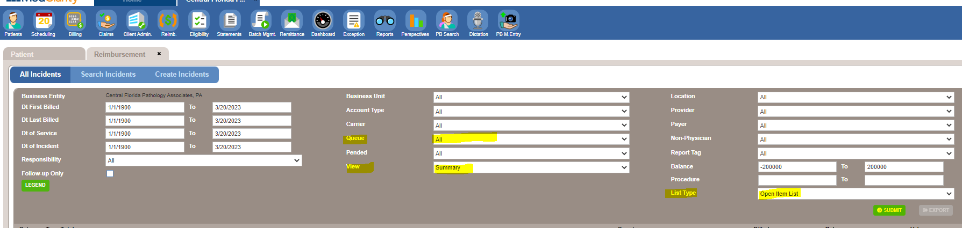
To find the claim, we can do "CTRL+F", then click the Claim ID, it will show you the CPT details billed in the claim.
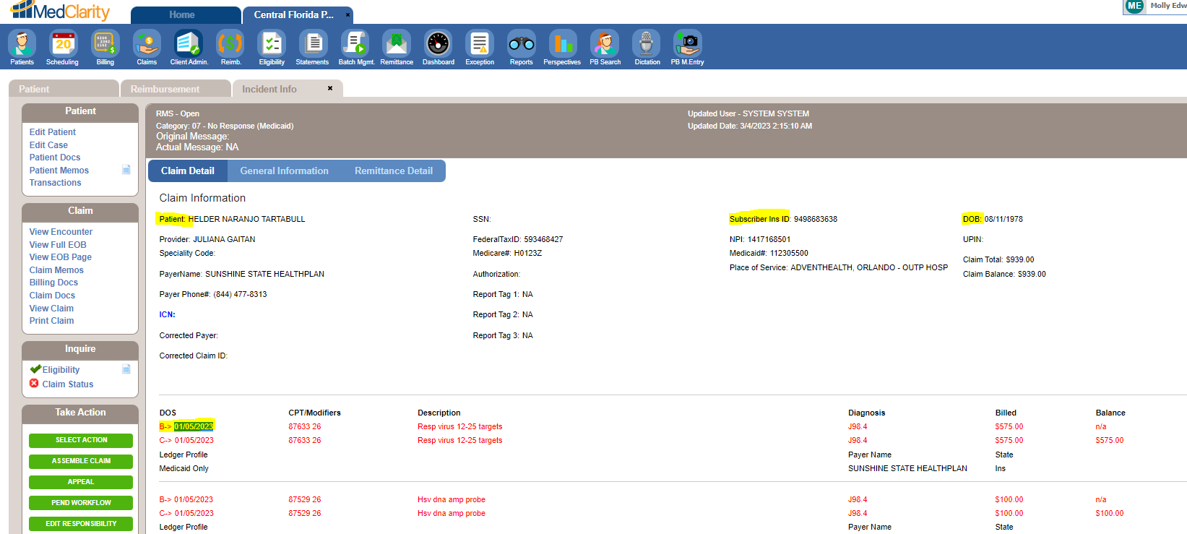
Now we have the patient information to check the claim status, enter the same in Sunshine portal.
Once all the Mandatory fields are entered need to click on Search which will pull the Claim status.
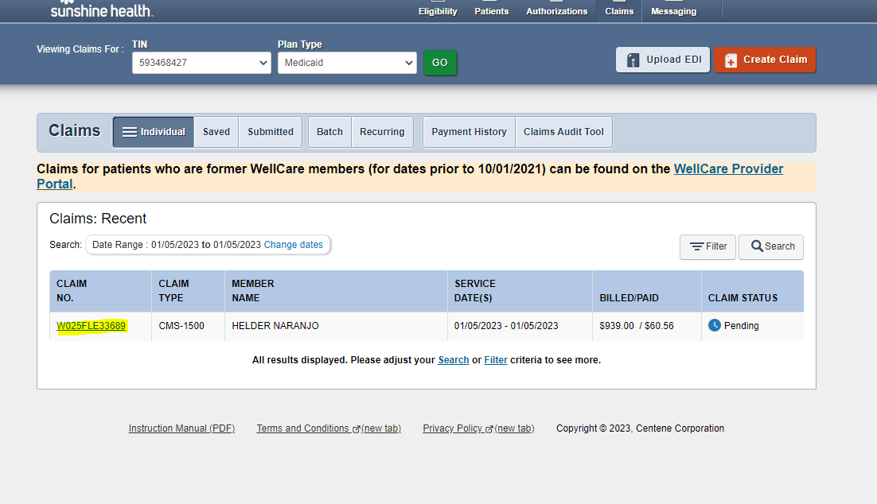
Now we have to click on Claim number to display the detailed claim status.
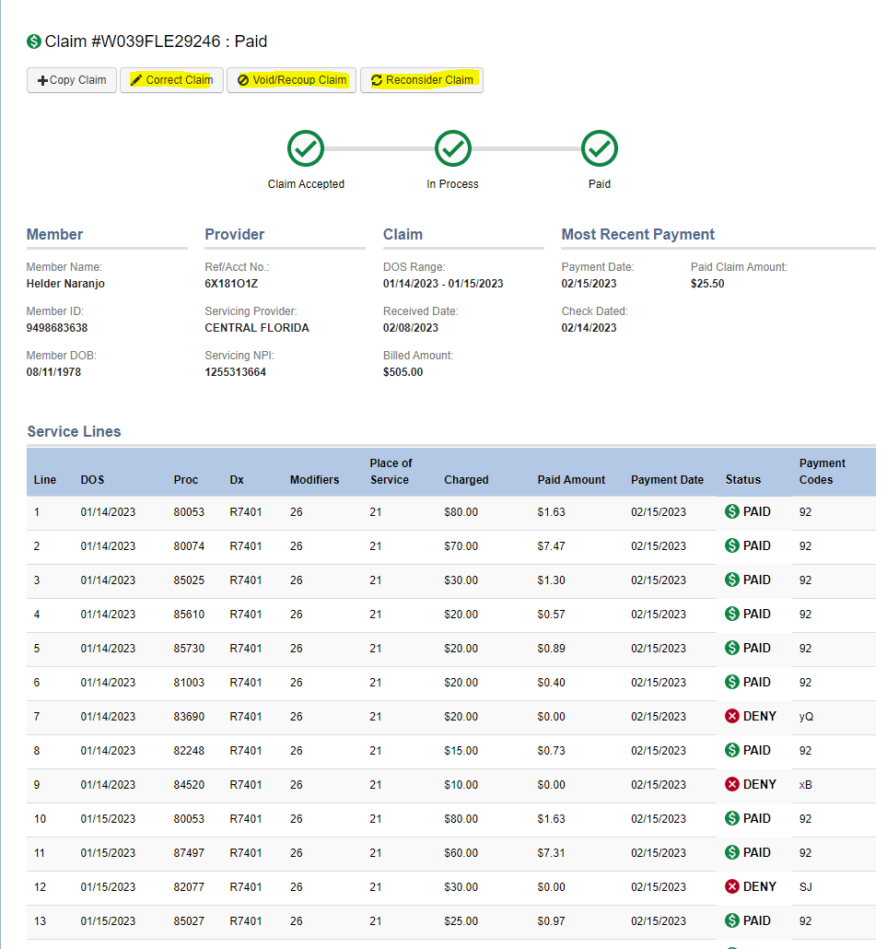

If we have any correction on the claim need to click on Correct Claim.
If we have to submit a reconsideration, need to click on Reconsider claim.
If we have to check patient Elligibility, need to check manually by Clicking on the Eligibility.
Then Enter the Date of service, Member ID or Last Name, Date of Birth.
Then click on Check Eligibility.
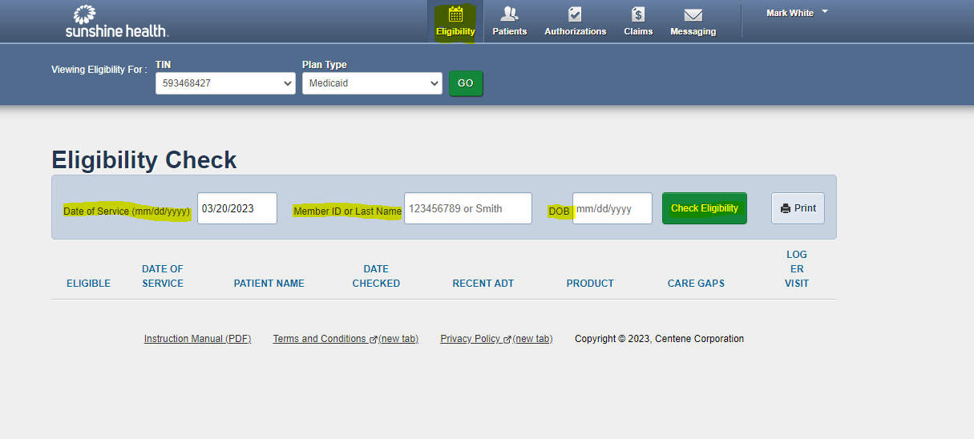
Once all the detials is entered click on Check eligibility to deplay detailed Eligibility status.
